**Project Report**

|  |  |
| --- | --- |
| **Team ID** | **PNT2022TMID19657** |
| **Project Name** | **Smart Waste Management System**  **For Metropolitan Cities** |
| **Team Lead** | **THASNEEM S** |
| **Team Member 1** | **PARTHASARATHY E** |
| **Team Member 2** | **SIVA GANESH S** |
| **Team Member 3** | **SURIYA VISHWA S C K** |
| **Team Member 4** | **THANYA V** |

1. **INTRODUCTION** 
   1. **Project Overview:**

Our continual increase in trash production has led to an international rubbish issue. Despite our efforts to make the world more sustainable and environmentally friendly, we continue to have problems with garbage generation and management. The ideal solution to this issue is to combine technological support with a vision of social, economic, and environmental sustainability. This is how it is carried out. To operate effectively, the smart bin system goes through a complete system check and battery level monitoring. If the battery level is low, it needs to be recharged right away before moving on to the next stage. Multiple sensors linked to the bin indicate the threshold level levels. If the garbage level is exceeded, an alert will sound.

* 1. **Purpose:**

We combine waste management with technology to efficiently create a secure and sanitary workplace. The goal of smart waste management is to make the waste business more effective by utilising technology and data. Smart trash management, which is based on Internet of Things (IoT) technology, intends to improve resource allocation, lower operating costs, and improve the sustainability of waste services. This not only enables the trash collectors who empty the bins to plan more effective routes, but also reduces the likelihood that any bin will be full for more than a week. Between the waste haulers and the information provided by technology, there is a strong degree of synchronisation. This makes them well aware of the existing garbage level and instigate them whenever the bins reach the threshold level. They are sent with alert messages so that they can collect the garbage on time without littering the surrounding area. The fill patterns of specific containers can be identified by historical data and managed accordingly in the long term. In addition to hardware solutions, mobile applications are used to overcome the challenges in the regular waste management system, such as keeping track of the drivers while they are operating on the field. Thus, smart waste management provides us with the most optimal way of managing the waste in an efficient manner using technology

1. **LITERATURE SURVEY:**

* 1. **Existing problem:**

In local towns and cities all around the world, waste management has grown to be a serious problem. Municipalities frequently have overflowing local dumpsters without being aware of it. This has a variety of effects on the locals, from the unpleasant odour to the hazardous and unclean environment. Poor waste management, which includes everything from nonexistent collection infrastructure to inefficient disposal, contaminates the air, water, and land. Open and unclean environments can infect people, spread diseases, and lead to the contamination of drinking water. As they accumulate throughout the food chain, toxic substances like persistent organic pollutants (POPs) pose particularly serious dangers to both human health and the ecosystem. Animals who consume polluted plants receive larger dosages of pollutants than those who are exposed to them directly. Hazardous elements from landfills, agricultural areas, feedlots, etc. will be absorbed by precipitation or surface water seeping through garbage and carried into surface and groundwater. Because it is frequently utilised for drinking, bathing, pleasure, as well as in agricultural and industrial processes, contaminated groundwater also offers a serious health danger. Various pests (insects, rodents, gulls, etc.) that seek out food in waste might be drawn to landfills and waste transfer terminals. These pests pose a threat to human health because they can transmit viruses and bacteria (such as salmonella and e-coli) that cause diseases.

* 1. **References:**

**PAPER 1:**

**TITLE:** IoT Based Waste Management for Smart City **AUTHOR NAME:** Parkash Tambare, Prabu Venkatachalam

**PUBLICATION YEAR:** 2016 **DESCRIPTION:**

The amount of waste created each day is increasing, and as a result, we frequently see that the trash cans or dust cans that are placed in public areas of cities are overflowing. We intend to build "IoT Based Waste Management for Smart Cities" to avoid this because it leads to unhygienic living conditions for people and offensive odours in the neighbourhood. The suggested system includes a large number of trash cans that are dispersed throughout the city or on the campus. Each garbage can has a low-cost integrated gadget that monitors its level as well as a unique ID that makes it possible to track and identify it.

**PAPER 2:**

**AUTHOR NAME:** Mohammad Aazam, Marc St-Hilaire,

Chung-Horng Lung, Ioannis Lambadaris **PUBLICATION YEAR:** 2016 **DESCRIPTION:**

The sensors in each bin of the Cloud SWAM system proposed by Mohammad Aazam et al can determine how much waste is there inside. For organic, plastic/paper/bottle/glass, and metal garbage, separate bins are available. In this manner, each type of waste is already separated, and the status makes it clear how much and what kind of waste is collected. The accessibility of cloud-stored data may be advantageous to various organisations and stakeholders in various ways. As soon as the trash is picked up, analysis and planning can start, and they can continue throughout recycling and import/export-related activities. The Cloud SWAM system offers prompt garbage pickup. The health, hygiene, and disposal conditions are improved by a timely and efficient garbage collection procedure.

**PAPER 3:**

**TITLE:** Arduino Microcontroller Based Smart Dustbins for Smart Cities

**AUTHOR NAME:** K. Suresh, S. Bhuvanesh and B. Krishna Devan

**PUBLICATION YEAR:** 2019 **DESCRIPTION:**

This paper describes a method for cleaning up our atmosphere and surroundings. The waste collection and disposal system needs to be upgraded for the Indian government's smart city plan to make these communities even smarter than they presently are. Self-Monitoring Automated Route Trash (SMART) dustbins are designed for usage in smart buildings, including among others universities, hospitals, and bus stations. In this project, we used the Servomotor to open the dustbin lid, the PIR and Ultrasonic sensors to detect human presence, and the Ultrasonic sensor to determine the amount of trash. A communication module is used to relay signals between two garbage cans, and the GSM module communicates the message to the operator.

**PAPER 4:**

**AUTHOR NAME:** Mohd Helmy Abd Wahab, Aeslina Abdul Kadir, Mohd Razali Tomari and Mohamad Hairol Jabbar

**PUBLICATION YEAR:** 2014 **DESCRIPTION:**

Proposed a smart recycle container that could manage the recycling of aluminium cans, plastic bottles, glass, and paper. After automatically calculating the worth of the garbage that was thrown away, a 3R card is generated. By putting rubbish in specified recycle bins, you can earn points under the recycling system. Such a system encourages recycling activities by allowing the points to be exchanged for goods or services. The system records details about disposal methods, materials disposed of, user identification, and points accumulated by the user. The user must tap his card to the designated RFID reader in order to access the recycle bin. Opening the recycling bin doors, garbage is placed one by one within.

**PAPER 5:**

**TITLE:** Waste Management Initiatives in India For Human Wellbeing **AUTHOR NAME:** Dr. Raveesh Agarwal, Mona Chaudhary and Jayveer Singh

**PUBLICATION YEAR:** 2015 **DESCRIPTION:**

This paper’s goal is to look at the current waste management practises employed in India to benefit the country's populace. The second objective is to provide suggestions for improving Indian municipal rubbish disposal methods. The foundation of this work is secondary research. The system is enhanced by taking a close look at the waste management reports that have already been published and the proposals for improvement made by planners, NGOs, consultants, government accountability organisations, and significant corporate leaders. It offers a thorough grasp of the various waste management initiatives in India and indicates potential areas for waste management improvement. The essay tries to understand the significant role that our country's official waste management sector plays in waste management process.

**2.3 Problem Statement Definition:**

|  |  |  |  |  |  |
| --- | --- | --- | --- | --- | --- |
| **Problem**  **Statement**  **(PS)** | **I am**  **(Customer)** | **I am trying to** | **But** | **Because** | **Which makes me**  **feel** |
| PS-1 | Council | Monitor the waste in my city | I have not much effective system  for monitoring | Because of high cost | unhygienic |
| PS-2 | Council | Manage  the waste in my city | I have not much  effective  system for managing | Because of more time consuming | unsafe |

1. **IDEATION & PROPOSED SOLUTION:**

* 1. **Empathy map canvas:**

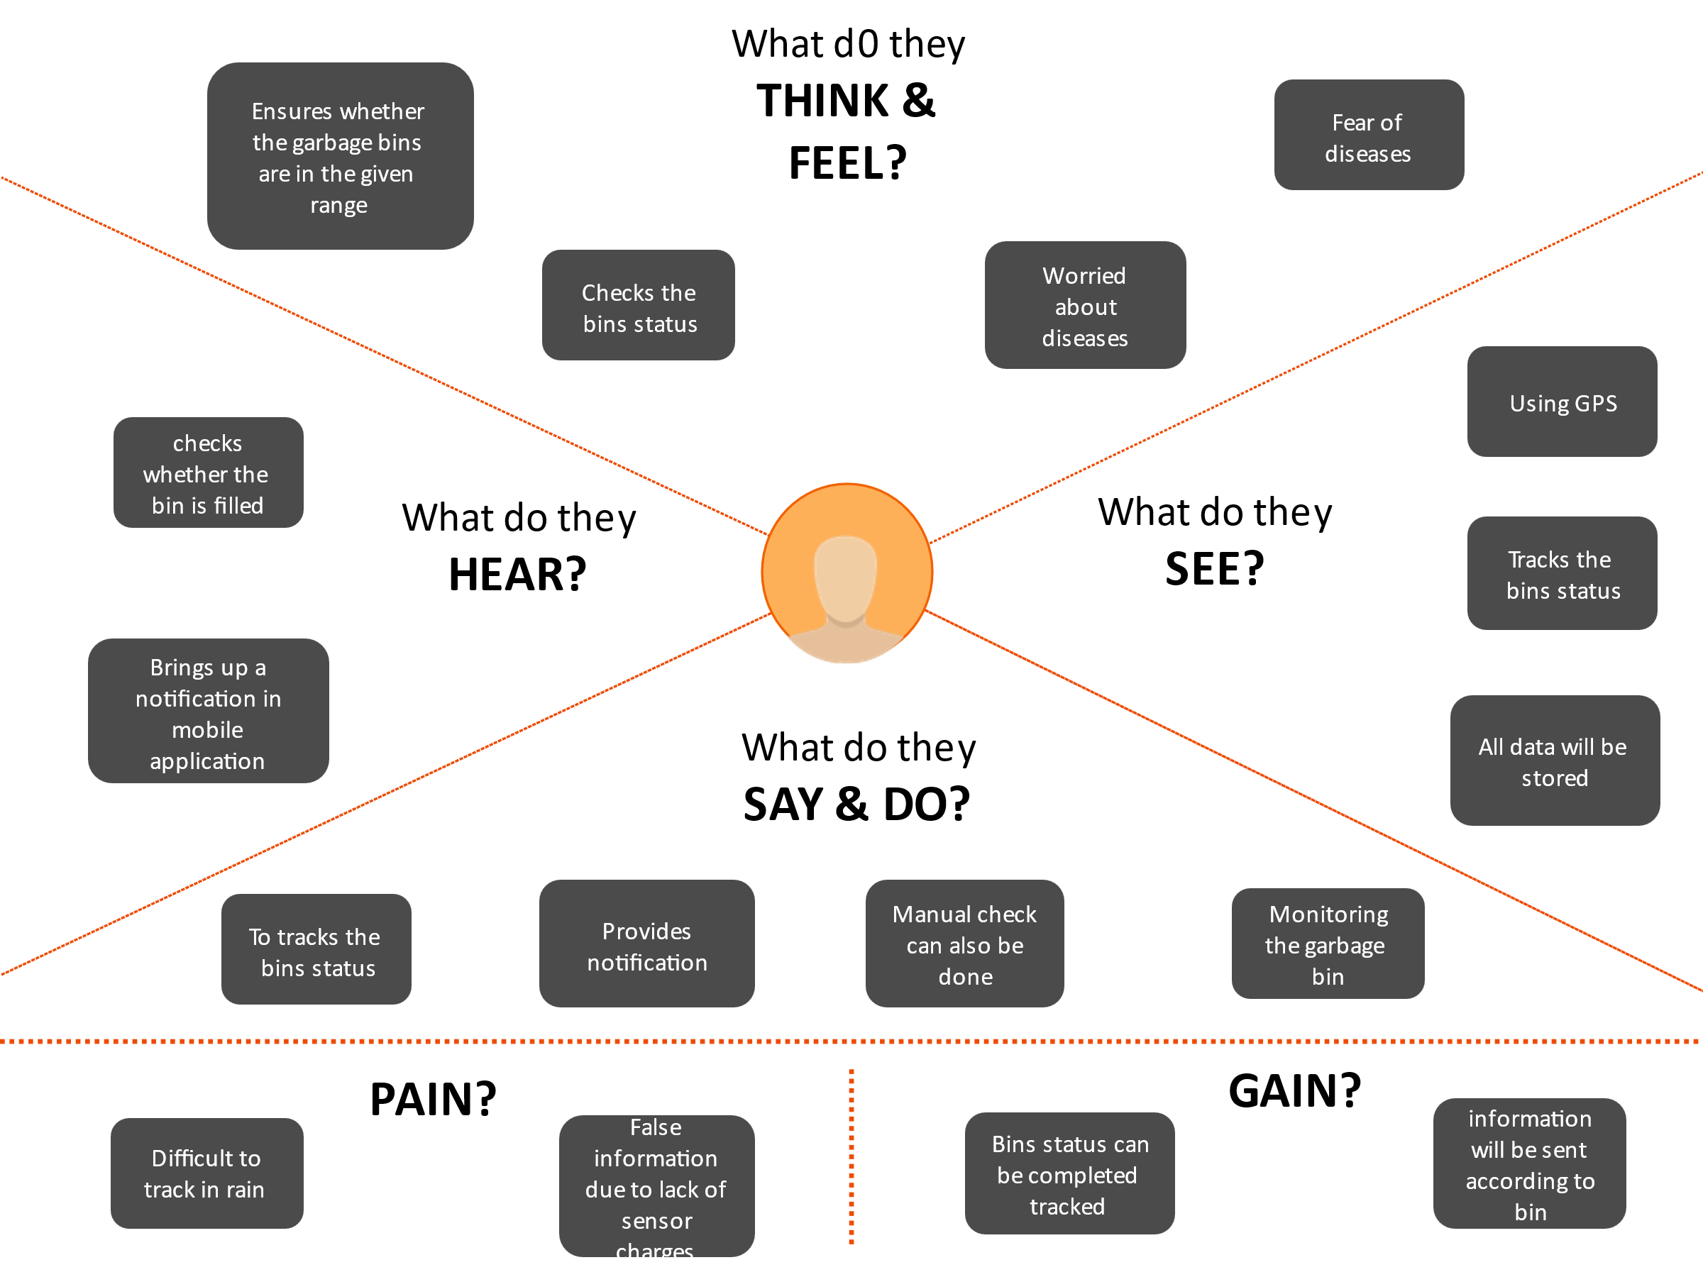

* 1. **Ideation & Brainstorming:**

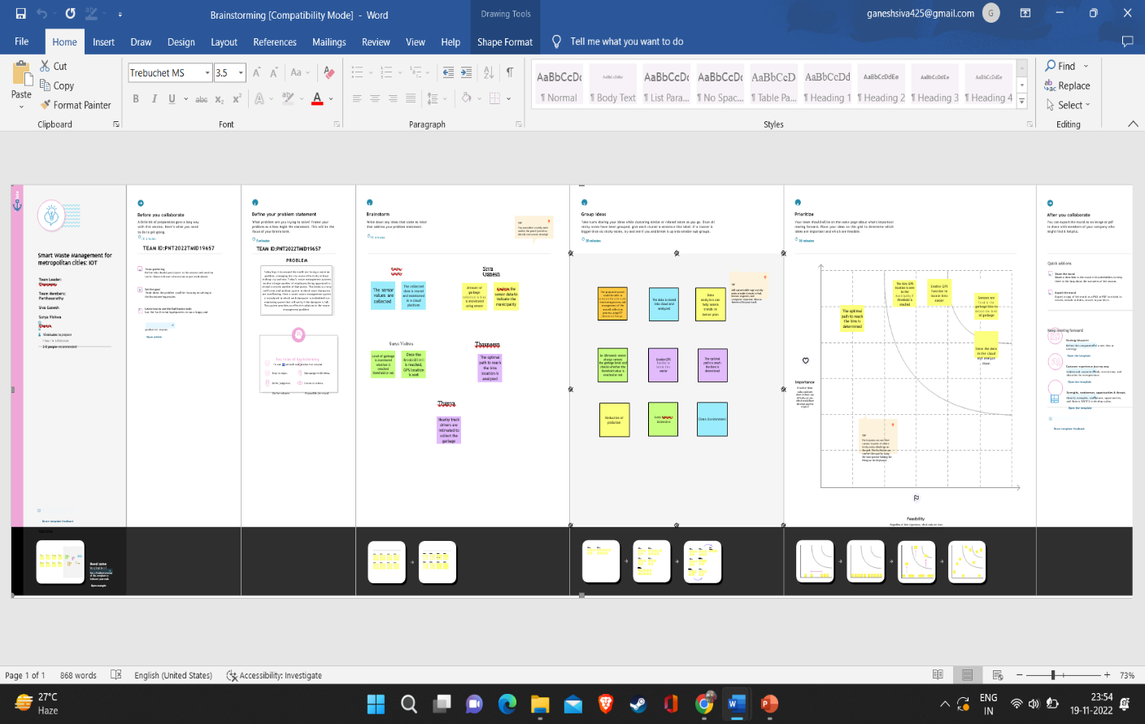

* 1. **Proposed Solution:**

|  |  |  |
| --- | --- | --- |
| **SI No.** | **Parameter** | **Description** |
| 1. | Problem Statement (Problem to be solved) | Detecting the level of garbage and informing the garbage collectors through a proper communication channel about the garbage level and alerts them to collect it at a specified time efficiently. |
| 2. | Idea / Solution description | By using fill level sensors we can detect the garbage level. Improving the communication channel using proper technology like WiMAX. Using GPS for tracking the location of bin and sorting out the short routes.  Using cloud service for the storage purpose. |
| 3. | Novelty / Uniqueness | By using IoT, GPS and GSM like technologies which if properly used in the establishment of this project helps to detect the garbage level and intimating about it to the authority and initiating them to collect the garbage on time. |
| 4. | Social Impact / Customer  Satisfaction | It keeps our surroundings clean and green and free from bad odour of wastes, emphasizes on healthy environment. Reduces air pollution |
| 5. | Business Model (Revenue Model) | Smart waste management system is an innovative and effective step to analyze the production of waste annually and it helps to find the ways to reduce the factors which increases the waste produced. |
| 6. | Scalability of the Solution | Smart waste management can attain its scalability by still more advancement in IoT and using many sensors to detect its  accurate level accurately. Its implementation can be enhanced by using  5G type of technology for faster communication. AI recycling robots can be used in the nearer future. |

* 1. **Problem solution fit:**

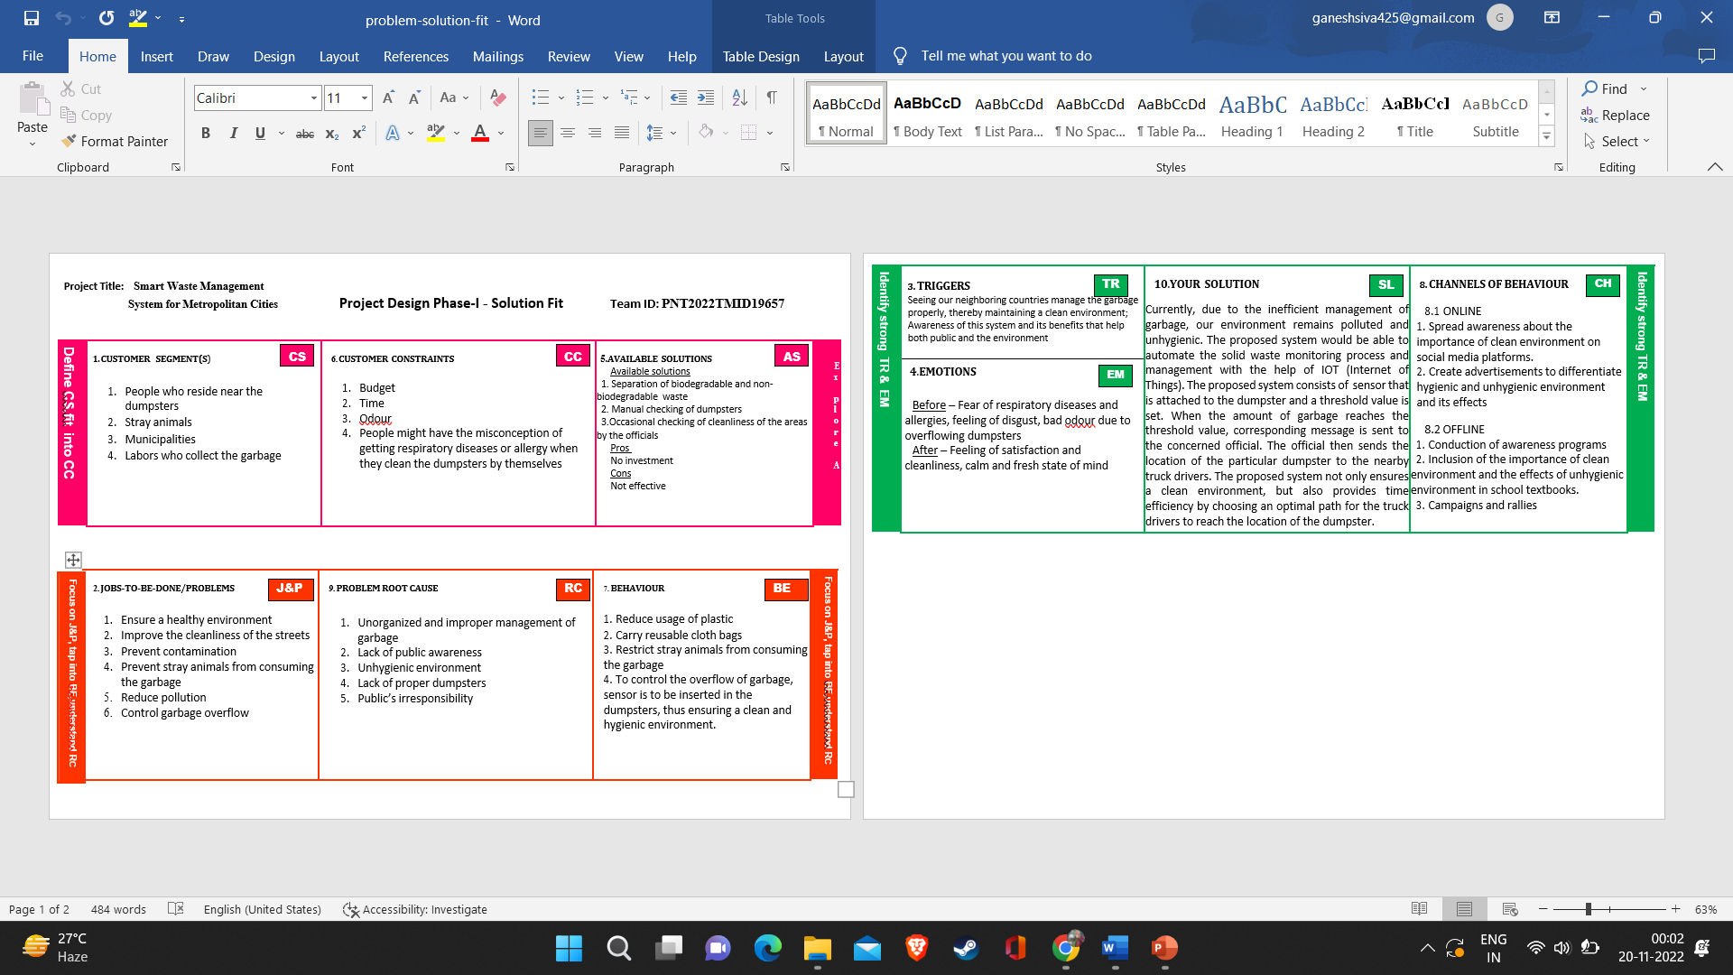

1. **REQUIREMENT ANALYSIS** 
   1. **Functional requirement**

|  |  |  |
| --- | --- | --- |
| **FR No.** | **Functional Requirement**  **(Epic)** | **Sub Requirement (Story / Sub-Task)** |
| FR-1 | Real time bin monitoring. | The Dashboard shows statistics on the amount of fill in bins as it is being tracked by smart sensors. The application also forecasts when the bin will fill up based on past data in addition to the percentage of fill level, which is one of the features that even the finest waste management software lacks. As picks are also recognized by the sensors, you can determine when the bin was last emptied. You can get rid of the overflowing bins and cease collecting half-empty ones using real-time data and forecasts. |
| FR-2 | Eliminate inefficient picks. | Get rid of the collection of half-empty trash cans. Picks are recognized by sensors. We can demonstrate to you how full the bins you collect are using real-time data on fill-levels and pick recognition. |
| FR-3 | Plan waste collection routes. | Route planning for rubbish pickup is semiautomated using the tool. You are prepared to act and arrange for garbage collection based on the levels of bin fill that are now present and forecasts of approaching capacity. To find any discrepancies, compare the planned and actual paths. |
| FR-4 | Adjust bin distribution. | Ensure the best possible bin distribution. Determine which regions have a dense or sparse distribution of bins. Ensure that each form of waste has a representative stand. You can make any required adjustments to bin position or capacity based on past data. |
| FR-5 | Expensive bins. | We assist you in locating containers that increase collection prices. The tool determines a collection cost rating for each bin. The tool takes local average depo-bin discharge into account. The tool determines the distance from depo-bin discharge and rates bins (1–10). |
| FR-6 | Detailed bin inventory. | On the map, you can see every monitored bin and stand, and you can use Google Street View at any time to visit them. On the map, bins or stands appear as green, orange, or red circles. The Dashboard displays information about each bin, including its capacity, trash kind, most recent measurement, GPS position, and pick-up schedule. |

* 1. **Non-Functional requirements:**

|  |  |  |
| --- | --- | --- |
| **FR No.** | **Non-Functional**  **Requirement** | **Description** |
| NFR-1 | **Usability** | Usability is a unique and significant perspective to examine user needs, which may further enhance the design quality, according to IoT devices. Analysing how well people interact with a product may help designers better understand customers' prospective demands for waste management, behaviour, and experience in the design process when user experience is at the Centre. |
| NFR-2 | **Security** | Utilize recyclable bottles. Utilize reusable shopping bags. Spend responsibly and recycle Eat and drink in limited-use containers. |
| NFR-3 | **Reliability** | Creating improved working conditions for garbage collectors and drivers is another aspect of smart waste management. Waste collectors will use their time more effectively by attending to bins that require service rather than travelling the same collection routes and servicing empty bins. |

|  |  |  |
| --- | --- | --- |
| NFR-4 | **Performance** | The Smart Sensors assess the fill levels in bins (along with othe data) numerous times each day using ultrasonic technology The sensors feed data to Senone’s Smart Waste Managemen Software System, a robust cloud-based platform with datadriven daily operations and a waste management app using a variety of IoT networks (NB-IoT, GPRS). As consequence, customers receive data-driven decision-making services, and garbage collection routes, frequency, and truck loads are optimized, resulting in at least a 30% decrease in route length. |
| NFR-5 | **Availability** | By creating and implementing robust hardware and gorgeous software, we enable cities, companies, and nations to manage garbage more intelligently. |
| NFR-6 | **Scalability** | Using smart trash bins allows us to scale up and monitor the rubbish more efficiently while also reducing the number of bins needed in towns and cities. |

r

1. **PROJECT DESIGN:** 
   1. **Data Flow Diagrams**:

A Data Flow Diagram (DFD) is a traditional visual representation of the information flows within a system. A neat and clear DFD can depict the right amount of the system requirement graphically. It shows how data enters and leaves the system, what changes the information, and where data is stored A smart waste management platform uses analytics to translate the data gather in your **bins into actionable insights to help you improve your waste services.** You can receive data on metric such as:

* + - The first test conducted is the situation where the garbage bin is empty or its garbage level is very low

* + - Then, the bin is filled with more garbage until its level has surpassed the first threshold **value, which is set to 80% then the first warning SMS is being sent, as depicted**
    - The first notification SMS sent by the system, once the waste reaches the level of 85% full
    - The second notification SMS sent by the system, indicating that bin is at least 95% full and **the garbage needs to be collected immediately**
    - Locations prone to overflow
    - The number of bins needed to avoid overflowing waste
    - The number of collection services that could be saved
    - The amount of fuel that could be saved
    - The driving distance that could be saved

**Data flow diagram:**

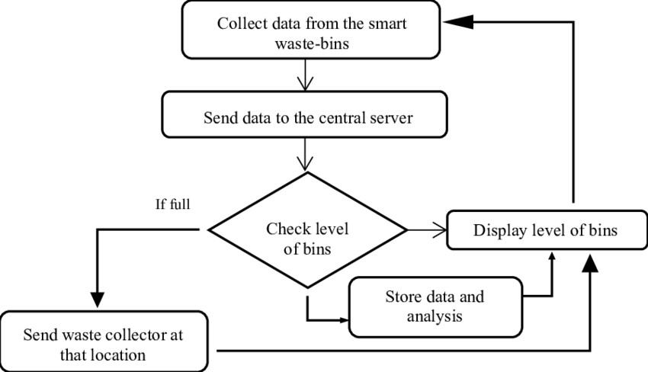

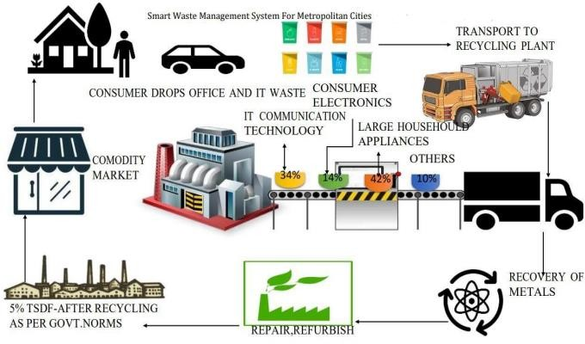

* 1. **Solution & Technical Architecture:**

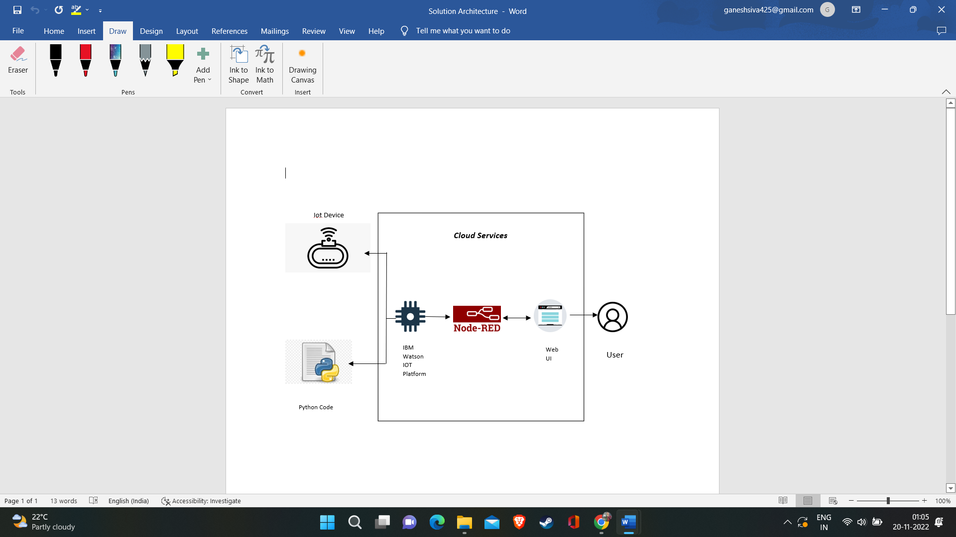

* 1. **User stories:**

|  |  |  |  |  |  |  |
| --- | --- | --- | --- | --- | --- | --- |
| **User Type** | **Functional**  **Requirement**  **(Epic)** | **User**  **Story**  **Number** | **User Story / Task** | **Acceptance**  **criteria** | **Priority** | **Release** |
| Admin(who  manages    server) | Web server login | USN-1 | As a admin, I  can able to track the truck driver name, id, contact number, location, and also the location of the dustbin. | I can  Manage and  direct  workers through web server | High | Sprint-1 |

|  |  |  |  |  |  |  |
| --- | --- | --- | --- | --- | --- | --- |
| Co-Admin | Login | USN-2 | As a co-admin  I’ll monitor the workers, whether the work has been done properly, checking the availability of workers and also monitor the waste collected by the truck driver within the scheduled time | I can monitor the garbage bin activity | High | Sprint-1 |
| Customer (Web user) | User | USN-3 | As a user , I can able to raise queries to higher authorities about the maintenance and disposal of waste | I can raise queries | Medium | Sprint-2 |
| Customer Care  Executive | Worker | USN-4 | As a customer care executive  I will try to rectify the queries from customers by contacting coadmin. In  case of  emergency  situation query can be reported to Admin. | I can attend calls and respond  people and  solve their problems | High | Sprint-1 |
| Truck driver | Worker | USN-5 | The truck driver is a  worker who has been assigned to collect the garbage and he have to report  to  admin about when and where and also the timings , the garbage has been picked up according the daily schedule. | I will do the work properly and report the data at the  scheduled  time | High | Sprint1 |

1. **PROJECT PLANNING & SCHEDULING:**

* 1. **Sprint Planning & Estimation:**

|  |  |  |
| --- | --- | --- |
| PHASE | TITLE | DESCRIPTION |
| Ideation Phase | Literature Survey &  Information Gathering | Literature survey on the selected project & gathering information by referring the, technical papers, research publications etc. |
| Prepare Empathy Map | Prepare Empathy Map Canvas to capture the user Pains & Gains, Prepare list of problem statements |

|  |  |  |
| --- | --- | --- |
|  | Ideation | List the by organizing the brainstorming session and prioritize the top 3 ideas based on the feasibility & importance. |
| Phase-1 | Proposed Solution | Prepare the proposed solution document, which includes the novelty, feasibility of idea, business model, social impact, scalability of solution, etc. |
| Problem Solution Fit | Prepare problem - solution fit document. |
| Solution Architecture | Prepare solution architecture document. |
| Phase-2 | Customer Journey | Prepare the customer journey maps to understand the user interactions & experiences with the application (entry to exit). |
| Functional Requirement | Prepare the functional and Nonfunctional requirement document. |
|  |  |
|  | Data Flow Diagrams | Draw the data flow diagrams and submit for review. |
| Technology Architecture | Prepare the technology architecture diagram. |
| Project planning phase | Prepare Milestone & Activity List | Prepare the milestones & activity list of the project. |
| Project development phase | Project Development -  Delivery of Sprint-1, 2, 3 & 4 | Develop & submit the developed code by testing it. |

* 1. **Sprint Delivery Schedule:**

|  |  |  |  |  |  |  |
| --- | --- | --- | --- | --- | --- | --- |
| **Sprint** | **Functional** | **User Story** | **User Story / Task** | **Story Points** | **Priority** | **Team** |
| **Requirement (Epic)** | **Number** | **Members** |
| Sprint-1 | Login | USN-1 | As a admin, I need to give access to both users and drivers for carring out the waste management system | 20 | High | Parthasarathy E |
| Sprint-2 | Dashboard | USN-2 | As a co-admin, i will manage the user request | 20 | High | Siva Ganesh S |
| And allocate, give instructions to drivers |
| Sprint-3 | Dashboard | USN-3 | As a Truck Driver, I’ll follow Admin’s | 20 | Medium | Suriya vishwa S C K |
| Instruction to reach the filling bin in short roots |
| and save time |
| Sprint-4 | Dashboard | USN-4 | As a officer. I will take care of reports | 20 | High | Thasneem S,  Thanya V |
| That are given by both the parties |

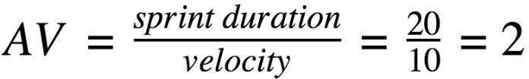

**Project Tracker, Velocity & Burndown Chart:**

|  |  |  |  |  |  |  |  |  |
| --- | --- | --- | --- | --- | --- | --- | --- | --- |
| **Sprint** | **Total Story** | **Duration** | **Sprint Start Date** | | **Sprint End Date** | | **Story Points** | **Sprint Release Date** |
| **Points** | **(Planned)** | | **Completed (as on** | **(Actual)** |
|  |  | | **Planned End Date)** |  |
| Sprint-1 | 20 | 6 Days | 24 | Oct 2022 | 29 | Oct 2022 | 20 | 29 Oct 2022 |
| Sprint-2 | 20 | 6 Days | 31 | Oct 2022 | 05 | Nov 2022 | 20 | 05 Nov 2022 |
| Sprint-3 | 20 | 6 Days | 07 | Nov 2022 | 12 | Nov 2022 | 20 | 12 Nov 2022 |
| Sprint-4 | 20 | 6 Days | 14 | Nov 2022 | 19 | Nov 2022 | 20 | 19 Nov 2022 |

* 1. **Reports from JIRA:**

**Burnout Chart:**

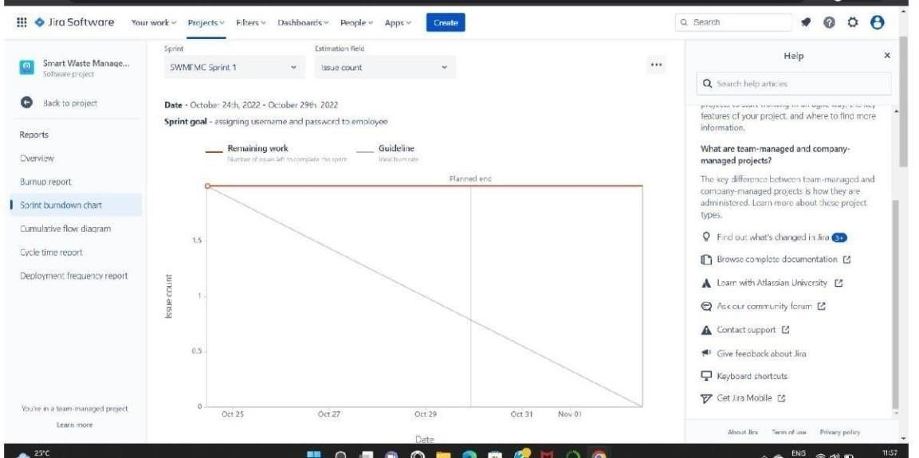

**Road map:**

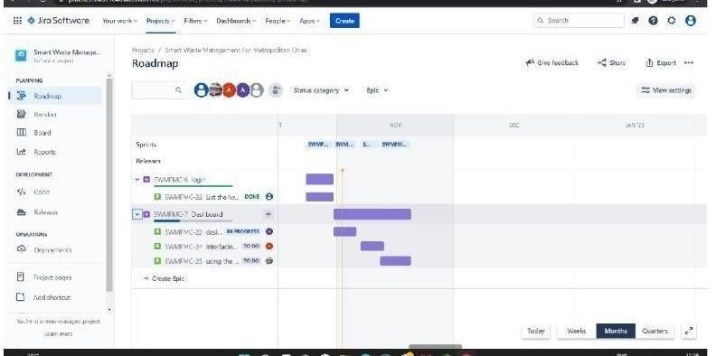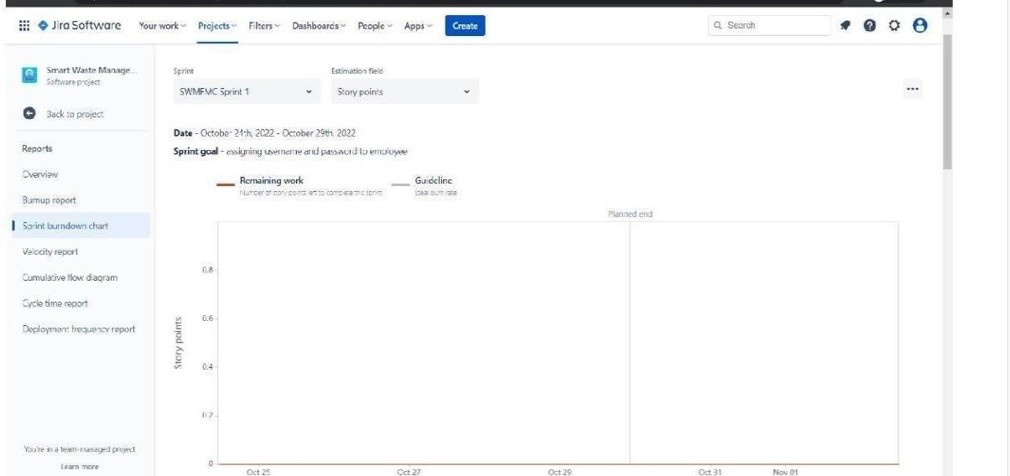

1. **CODING & SOLUTIONING:**

* 1. **Feature 1- LOCATION TRACKER:**

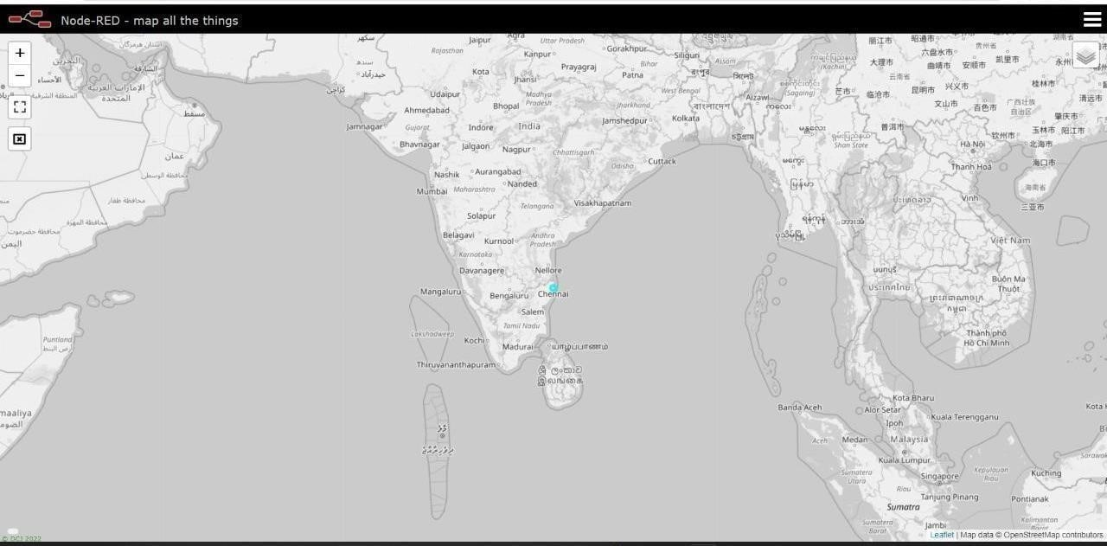

* 1. **Feature 2- LIVE UPDATE ON COLLECTED DATA:**

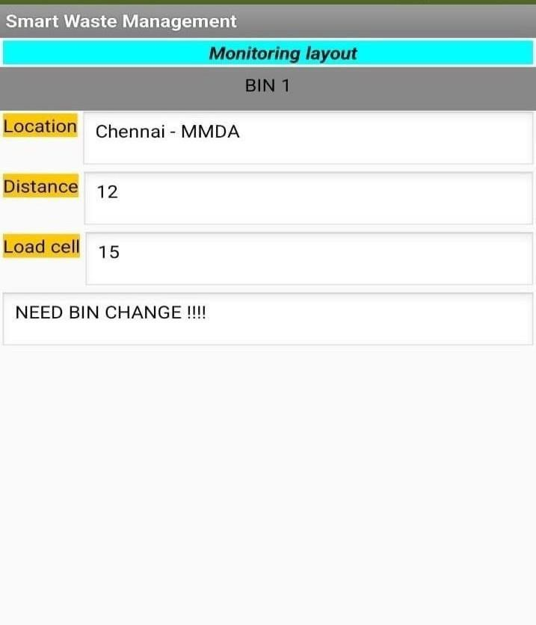

1. **Testing:** 
   1. **Testcases:**

|  |  |  |  |  |  |  |  |  |  |  |  |  |  |
| --- | --- | --- | --- | --- | --- | --- | --- | --- | --- | --- | --- | --- | --- |
| TEST  CASE ID | FEATUR  E TYPE | COM  PO  NENT | TEST  SCENARI  O | PR  ER  EQ  UIS  ITE | STEPS  TO  EXEC  UT  E | TEST  DATA | EXPEC  TED  RESUL  T | ACTU  AL  RESUL  T | STAT  U S | CO  MM  ENT  S | TC  FOR  AUTO  M  ATIO  N(  Y/N) | BU  G  ID | EXECUTED BY |
| LOGIN | FUNCTI | HOM | VERIFY |  | 1.ENT | https:// | L0gin | Workin | PASS | **Suc** |  |  | **THASNEEM S** |
| PAGE_TC | ONA L | E | THE USER |  | ER | 1 | page is | g as |  | **cess** |  |  |  |
| _001 |  | PAGE | IS ABLE |  | URL | 69.51.2 | visible | expecte |  | **ful** |  |  |  |
|  |  |  | TO SEE |  | AND | 0 |  | d |  |  |  |  |  |
|  |  |  | THE |  | CLICK | 4.219.3 |  |  |  |  |  |  |  |
|  |  |  | LOGIN/SI |  | GO | 0 |  |  |  |  |  |  |  |
|  |  |  | G |  | 2.VER | 106 |  |  |  |  |  |  |  |
|  |  |  | N UP |  | IFY |  |  |  |  |  |  |  |  |
|  |  |  | WEN |  | LOGI |  |  |  |  |  |  |  |  |
|  |  |  | USER |  | N/SI |  |  |  |  |  |  |  |  |
|  |  |  | CLICK ON |  | GN |  |  |  |  |  |  |  |  |
|  |  |  | MY  ACCOUNT  BUTTON |  | UP |  |  |  |  |  |  |  |  |

|  |  |  |  |  |  |  |  |  |  |  |  |  |  |
| --- | --- | --- | --- | --- | --- | --- | --- | --- | --- | --- | --- | --- | --- |
| LOGIN  PAGE_TC  _002 | UI | HOM  E  PAGE | VERIFY  THE USER  IS ABLE  TO SEE  THE  LOGIN/SI  G  N UP  WEN  USER  CLICK ON  MY  ACCOUNT  BUTTON |  | 1.ENT  ER  URL  AND  CLICK  GO  2.VER  IFY  LOGI  N/SI  GN  UP Eleme nts  a.ID text b o  x B  .  passw ord text  box  c..logi n butto n D.ne w user E.alre ady have an  accou nt | https:// 1  69.51.2  0  4.219.3  0  106 | Applicat ion should show  below UI elemen  t | Workin  g as expecte d | PASS | Succ ess ful**l** |  |  | **THANYA V** |

|  |  |  |  |  |  |  |  |  |  |  |  |  |  |  |  |  |  |  |  |  |  |  |  |  |  |  |
| --- | --- | --- | --- | --- | --- | --- | --- | --- | --- | --- | --- | --- | --- | --- | --- | --- | --- | --- | --- | --- | --- | --- | --- | --- | --- | --- |
| LOGIN  PAGE_TC  _003 | FUNCTI  ONA L | | LOGI  N  PAGE | | VERIFY  THE USER  IS ABLE  TO SEE  THE  LOGIN/SI  G  N UP  WEN  USER  CLICK ON  MY  ACCOUNT  BUTTON | |  | 1.ent er url and  click go  2.click on my accou nt 3.Ent er valid ID 4.Ent er  valid  passw ord  5.click on login | | | Id:1111  passwo  r  d:5678 | User should navigat e  your home page. | | | Workin  g as expecte d | | PASS | | Succ ess ful |  | |  | | | **THANYA V** | |
|  |  | |  | |  | |  | butto n | | |  |  | | |  | |  | |  |  | |  | | |  | |
| LOGIN | FUNCTI  ONA | | LOGI  N | | VERIFY | |  | 1.ent er url | | | Id:1111 | Confirm | | | Workin | | PASS | | Succ ess |  | |  | | | **SIVA GANESH S** | |
| PAGE_TC_  004 | | | L | | PAGE | | THE USER  IS ABLE  TO SEE  THE  LOGIN/SIG  N UP WEN  USER  CLICK ON  MY  ACCOUNT  BUTTON | | |  | and click go  2.click on my account 3.Enter valid ID 4.Enter valid password  5.click on login butvton | | | pass wor d:56  78 | ation message sent | | g as expecte d | |  | | | ful | |  |  | |  |
| LOGIN  PAGE_TC_  005 | | | UI | | LOGIN PAGE | | VERIFY  THE USER  IS ABLE  TO SEE  THE  LOGIN/SIG  N UP WEN  USER  CLICK ON | | |  | 1.enter url and click go  2.click on my account 3.Enter valid ID 4.Enter valid | | | Id:1 111 pass wor d:56 78 | Confirm ation  message sent | | Workin  g as expecte d | | PASS | | | Success ful | |  |  | | **SURIYA VISHWA S C K** |
|  | | |  | |  | | MY | | |  | password | | |  |  | |  | |  | | |  | |  |  | |  |
|  | | |  | |  | | ACCOUNT | | |  | 5.click | | |  |  | |  | |  | | |  | |  |  | |  |
|  | | |  | |  | | BUTTON | | |  | on login button | | |  |  | |  | |  | | |  | |  |  | |  |
| LOGIN  PAGE_TC_  006 | | | FUNCTIONA  L | | LOGIN  PAGE  FOR  ADMIN | | VERIFY  THE USER IS ABLE  TO SEE  THE  LOGIN/SIG N UP WEN  USER  CLICK ON  MY  ACCOUNT  BUTTON | | |  | 1.enter url and click go  2.click on my account 3.Enter valid ID 4.Enter valid password  5.click on login button | | | Id:1 111 pass wor d:56  78 | Custom  er  databas e is visible | | Workin  g as expecte d | | PASS | | | Success ful | |  |  | | **PARTHASARATHY E** |

* 1. **User acceptance Testing:**

1. **Purpose of Document**

The purpose of this document is to briefly explain the test coverage and open issues of the [ProductName] project at the time of the release to User Acceptance Testing (UAT).

1. **Defect Analysis**

This report shows the number of resolved or closed bugs at each severity level, and how they were resolved

|  |  |  |  |  |  |
| --- | --- | --- | --- | --- | --- |
| **Resolution** | **Severity 1** | **Severity 2** | **Severity 3** | **Severity 4** | **Subtotal** |
| By Design | 10 | 4 | 2 | 3 | 20 |
| Duplicate | 1 | 0 | 3 | 0 | 4 |
| External | 2 | 3 | 0 | 1 | 6 |
| Fixed | 11 | 2 | 4 | 20 | 37 |

|  |  |  |  |  |  |
| --- | --- | --- | --- | --- | --- |
| Not  Reproduced | 0 | 0 | 1 | 0 | 1 |
| Skipped | 0 | 0 | 1 | 1 | 2 |
| Won't Fix | 0 | 5 | 2 | 1 | 8 |
| Totals | 24 | 14 | 13 | 26 | 7 |

**1. Test Case Analysis:**

This report shows the number of test cases that have passed, failed, and untested

|  |  |  |  |  |
| --- | --- | --- | --- | --- |
| **Section** | **Total**  **Cases** | **Not**  **Tested** | **Fai l** | **Pas s** |
| Print Engine | 7 | 0 | 0 | 7 |
| Client Application | 51 | 0 | 0 | 51 |
| Security | 2 | 0 | 0 | 2 |
| Outsource Shipping | 3 | 0 | 0 | 3 |
| Exception Reporting | 9 | 0 | 0 | 9 |
| Final Report Output | 4 | 0 | 0 | 4 |
| Version Control | 2 | 0 | 0 | 2 |

1. **RESULTS:**

**9.1 Performance Metrics:**

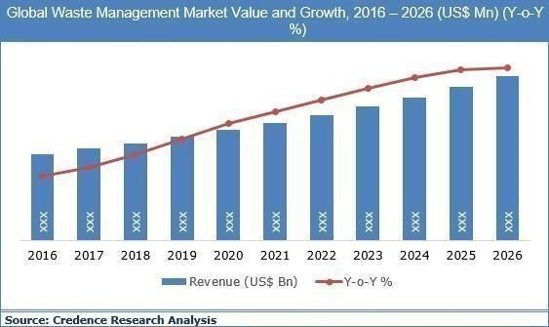

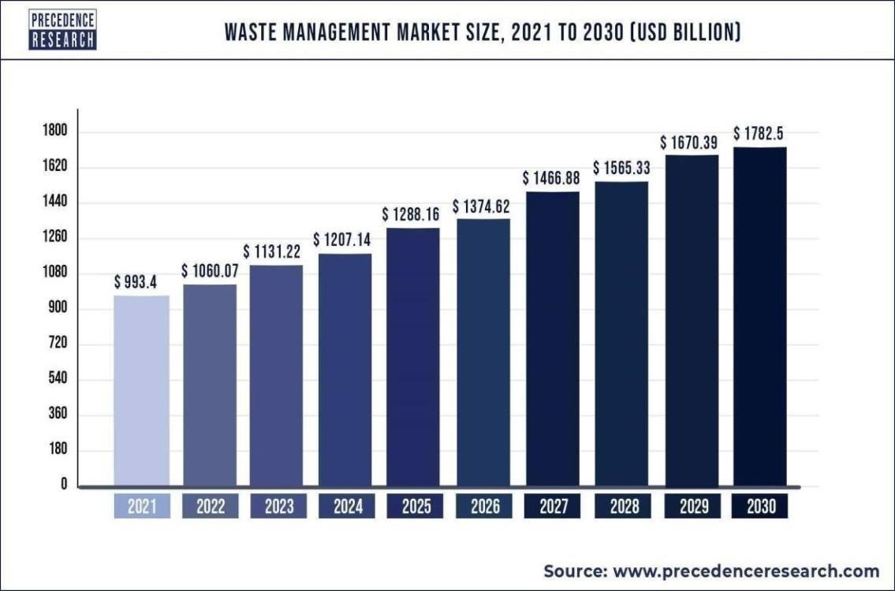

1. **ADVANTAGES & DISADVANTAGES**

**ADVANTAGES:**

* + Reduction in Collection Cost
  + No Missed Pickups
  + Reduced Overflows
  + Waste Generation Analysis • CO2 Emission Reduction

**DISADVANTAGES:**

The system requires more trash cans than the city's population, which results in a higher initial cost because smart trash cans are more expensive than those used by other systems. The dustbin sensor nodes only have a little amount of memory.

1. **CONCLUSION:**

By employing sensors to track the filling of bins, a Smart Waste Management system that is more effective than the one now in use can be created. Our idea of a "smart waste management system" focuses on tracking waste management, providing intelligent technology for waste systems, doing away with human intervention, reducing human time and effort, and creating a clean, healthy environment. In smart cities where citizens have hectic schedules that provide little time for garbage management, the suggested solution can be put into practise. If desired, the bins might be placed in a city where a big enough container could carry enough solid waste for one unit. But the cost can be a little high.

1. **FUTURE SCOPE:**

There are several future works and improvements for the proposed system, including the following:

1. Change the system of user authentication and atomic lock of bins, which would aid in protecting the bin from damage or theft.
2. The concept of green points would encourage the involvement of residents or end users, making the idea successful and aiding in the achievement of collaborative waste management efforts, thus fulfilling the idea of Swachh Bharath.
3. Having case study or data analytics on the type and times waste is collected on different days or seasons, making bin filling predictable and removing the reliance on electronic components, and fixing the coordinates.
4. Improving the Server's and Android's graphical interfaces

**13. Appendix:**

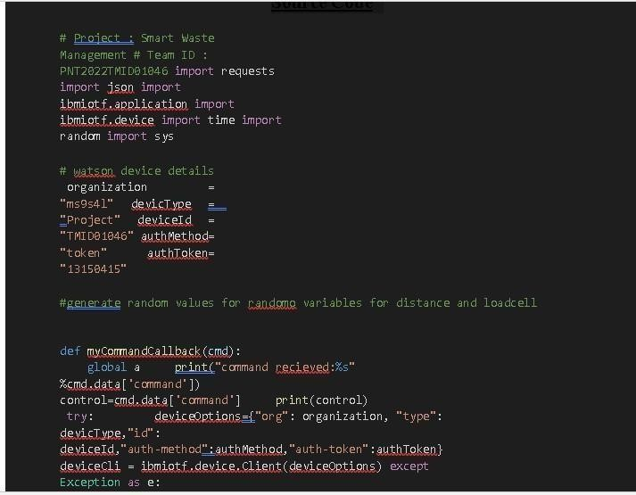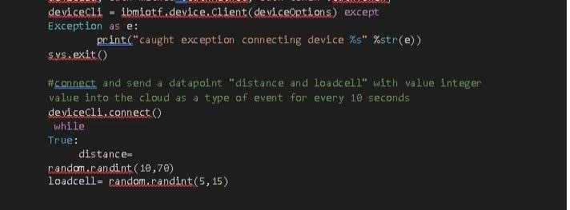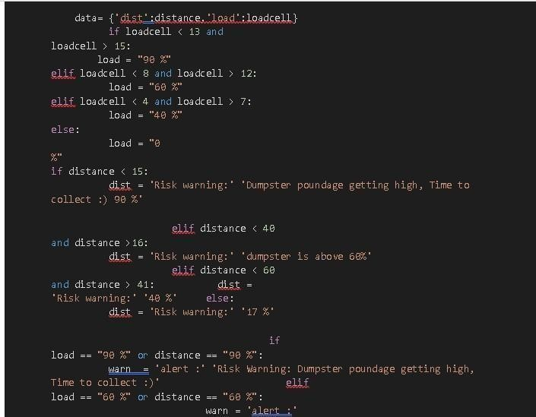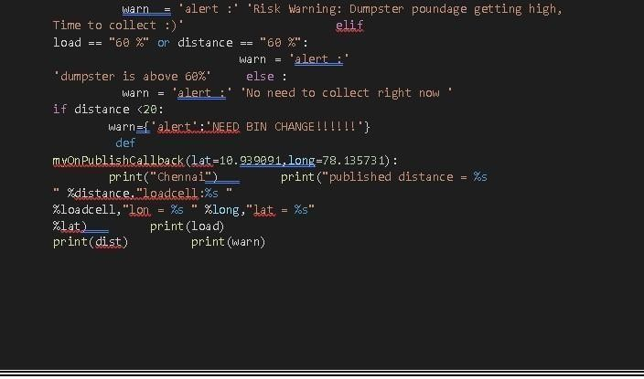

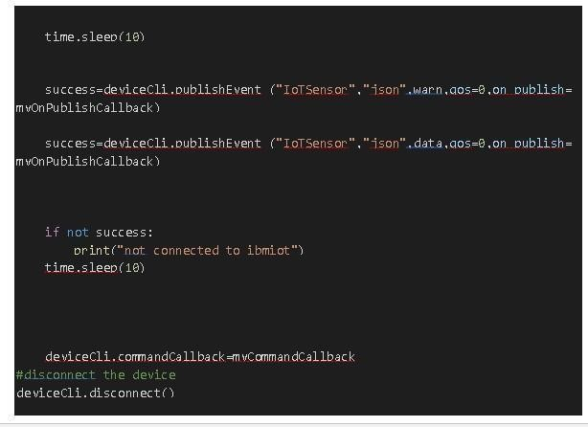

**GitHub Link:**

https://github.com/IBM-EPBL/IBM-Project-4537-1658734132

